Borderlands Mexico Port of Brownsville completes $295M ship channel deepening project

Noi Mahoney, Sunday, June 28, 2026
Original Article: https://www.freightwaves.com/news/borderlands-mexico-port-of-brownsville-completes-295m-ship-channel-deepening-project
Articles Reproduced by Permission of FreightWaves

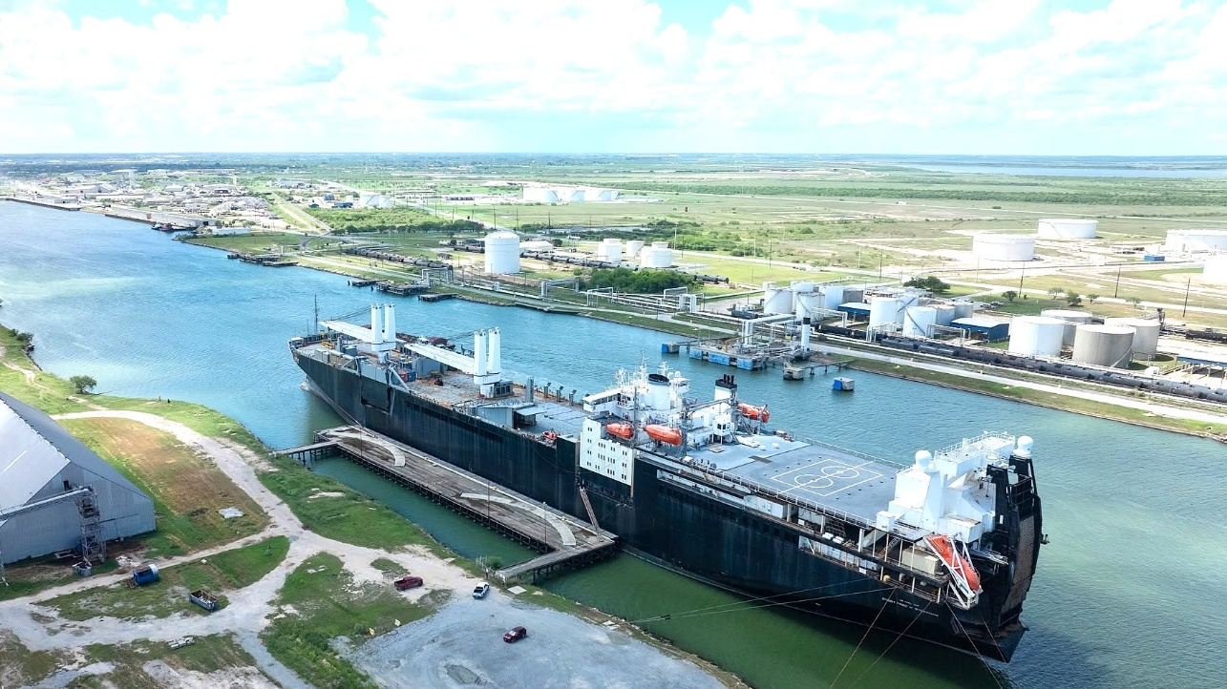
The completed Brazos Island Harbor Improvement Project increases vessel draft by 10 feet, allowing ships to carry significantly more cargo while enhancing the Port of Brownsville's competitiveness, officials said. (Photo: Port of Brownsville)

Borderlands Mexico is a weekly rundown of developments in the world of United States-Mexico cross-border trucking and trade. This week in Borderlands Mexico: Port of Brownsville completes $295M ship channel deepening project; Palmer Holland expands into Mexico with Querétaro operations; and TexAmericas Center in line for proposed $500M battery-materials project.

Port of Brownsville completes $295M ship channel deepening project
The Port of Brownsville has completed the $295.2 million Brazos Island Harbor Improvement Project, an infrastructure investment that deepens the Brownsville Ship Channel by 10 feet.

The aim of the project is to position the South Texas port to handle larger cargo vessels, expand energy exports and compete for new maritime business.

“The deeper channel changes what the Port of Brownsville can do operationally,” Port Director and CEO William Dietrich said in a news release. “It increases our ability to accommodate larger, more fully loaded vessels, improve cargo efficiency and compete for maritime business that previously faced depth limitations.”

Located 277 miles south of San Antonio at the southernmost tip of Texas along the Gulf of Mexico, the 17-mile Brownsville Ship Channel at the Port of Brownsville is the only deep-water seaport located along the border, making it a major trade channel between Texas and Mexico.

More than 80% of the port’s trade is with Mexico, moving commodities such as steel, petroleum products and industrial cargo, making it a critical gateway for cross-border commerce.

The project deepened the channel’s main navigation route from 42 feet to 52 feet while increasing the entrance and jetty channels from 44 feet to 54 feet.

Brownsville Navigation District Chairman Sergio “Tito” Lopez said the project represents decades of planning and investment.

“This is a generational change,” Lopez said. “This is going to transform our port tremendously.”

Palmer Holland expands into Mexico with Querétaro operations
Specialty chemical and ingredient distributor Palmer Holland has expanded into Mexico, establishing its first operations in the country as part of a broader strategy to grow its presence across North America and Latin America.

The Cleveland-based company said the expansion includes a fully operational legal entity in Mexico, warehouse operations in Querétaro, locally based account managers and Spanish-speaking operations personnel to support customers and suppliers nationwide.

“Our expansion into Mexico is a natural evolution of Palmer Holland’s North American growth strategy,” CEO Tim Skufca said in a news release. “By investing in people and operational capabilities, we are positioning ourselves to provide faster response times, stronger technical support, and greater supply chain continuity.”

The company said its presence in Querétaro will allow it to leverage its North American distribution network while providing localized service to customers across the country.

TexAmericas Center in line for proposed $500M battery-materials project
TexAmericas Center could land a commercial-scale battery-materials manufacturing project representing about $500 million in potential investment in Northeast Texas.

The proposed project is tied to a joint venture between EnergyX and Wildcat Discovery Technologies to develop a lithium iron phosphate cathode active material manufacturing facility in the Texarkana area. EnergyX has secured site control for about 330 acres at TexAmericas Center as it evaluates future development.

The project is not final and remains subject to EnergyX exercising its option to purchase the site, securing approvals, obtaining financing and completing development milestones. Wildcat’s proposed co-location would depend on EnergyX moving forward with the larger commercial project.

EnergyX has already invested about $20 million in an existing demonstration-scale project. The larger facility under evaluation at TexAmericas Center would represent about $500 million in potential investment and could produce about 15,000 metric tonnes per year of lithium iron phosphate cathode active material in its first phase, with room to expand in later phases.

The companies said the facility would support battery components used in energy storage systems, electric vehicles, defense platforms, drones and other advanced energy applications. The proposed facility would be located near EnergyX’s Project Lonestar lithium plant and the U.S. Army’s Red River Army Depot.

TexAmericas Center owns and operates nearly 12,000 acres and approximately 3.5 million square feet of industrial, warehouse, office and logistics space. The industrial park also includes an on-site 350-car rail yard and more than 30 miles of rail running through its properties.

